**GSRS AUTOMATOR 1.0**

**USER MANUAL**

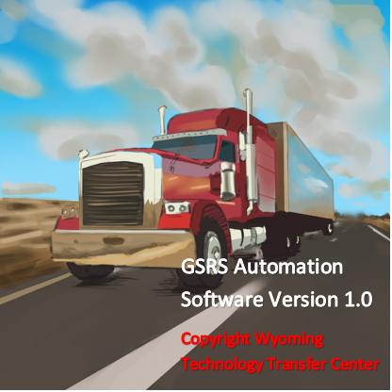

**Developed By**

**Wyoming Technology Transfer Center**



Table of Contents

PRODUCT INFORMATION 3

SYSTEM REQUIREMENTS 3

INSTALLATION PROCEDURE 4

PRODUCT FEATURES 10

DATA PREPARATION 13

CONTINUOUS SLOPE METHOD 15

SEPARATE DOWNGRADE METHOD 17

ERROR HANDLING 20

Table of Figures

Figure 1 Login Page. 10

Figure 2 User Registration Form. 10

Figure 3 User Registration Form illustrating a data-entry process. 11

Figure 4 An Example of Final Output of Maximum Descent Speeds and Other Parameters Based on the Continuous Slope Method. 12

Figure 5 Entering the physical downgrade parameters manually. 13

Figure 6 Importing the physical downgrade parameters from excel. 14

Figure 7 A Snapshot for a Sample Excel Datasheet representing the Physical Characteristics of the Downgrade and the Roadway Geometry. 14

Figure 8 An Example of Final Output and Temperature profile of Maximum Descent Speeds based on the Continuous Slope Method. 16

Figure 9 Aerial view of a typical multigrade segment. 17

Figure 10 A Snapshot for a Sample Excel Datasheet representing the Physical Input Parameters for the Braking Phase. 17

Figure 11 An Example of the Final Output of Maximum Descent Speeds and Other Parameters for a Typical Braking Phase based on the Separate Downgrade Method. 18

Figure 12 A Snapshot of the Excel Data File containing the Physical Input Parameters of the Non-Braking Phase. 19

Figure 13 An Example of Final Output of Maximum Descent Speeds and Other Parameters for a Typical Non-Braking Phase Based on the Separate Downgrade Method. 19

Figure 14 Error Dialogue box for data entered in incorrect format. 20

Figure 15 Error Dialogue box for data values violating criteria for in-built equations. 20

# PRODUCT INFORMATION

GSRS Automator 1.0 is the maiden version of the GUI-based software developed to automate the most recent advances in the Grade Severity Rating System primarily for downgrades in the mountainous regions of Wyoming. As opposed to prior console-based versions of the computer program based on older mathematical models, the GSRS Automator provides a much higher level of intuitiveness, aesthetic appeal, interactiveness and user-friendliness through a Graphical User Interface provided by the Visual Basic.net object-oriented programming language. This document details the hardware and operating system requirements for installation of the product for optimal performance, the input parameters and how to interpret the output data generated by the product. The software can only be used on a single computer at a time since this particular version does not support networking. The product requirements are as follows:

# SYSTEM REQUIREMENTS

Designed to run optimally on Microsoft Windows version 10.

Minimum of 256 MB RAM is recommended.

Minimum of 3 GB of Hard Disk space required to install this application. A breakdown of the allocation of this space as per required pre-requisite software installations prior to the use of this program is provided in the table below;

|  |  |  |
| --- | --- | --- |
| **HARD DRIVE CAPACITY REQUIREMENTS** |  |  |
| Microsoft VSS writer for SQL Server 2019 | 1.78 | MB |
| Microsoft SQL Server Management Studio- 18.9.2 | 2660 | MB |
| Microsoft SQL Server 2019 T- SQL Language Service | 9.05 | MB |
| Microsoft SQL Server Setup (English) | 184 | MB |
| Microsoft SQL Server 2012 Native Client | 8.33 | MB |
| Microsoft OLE DB Driver for SQL Server | 8.28 | MB |
| Microsoft ODBC Driver 17 for SQL Server | 7.01 | MB |
| GSRS Automator | 3.23 | MB |
| Browser for SQL Server 2019 | 11 | MB |
|  |  |  |
| **Total** | 2892.68 | MB |
| **Total** | 3 | GB |

# INSTALLATION PROCEDURE

Install Pre-requisites:

1. Unzip “GSRS Automation 2021 v2 Setup.zip” to “C:\ drive”
2. Open folder “C:\GSRS Automation 2021 v2 Setup\”
3. Install SQLExpress 2019 by clicking on “SQL Express 2019.exe”
   1. Select Basic Option
   2. Continue with Install process till end
4. Install Microsoft SQL Server Management Studio by clicking on “SQL Mgmt Studio.exe”. If any errors are encountered in installing this software, please download a new version from the following web location: https://docs.microsoft.com/en-us/sql/ssms/download-sql-server-management-studio-ssms?view=sql-server-ver15
5. Open Microsoft SQL Server Management Studio using the shortcut on the desktop “Microsoft SQL Server Management Studio 18” or access it from the Windows Start menu

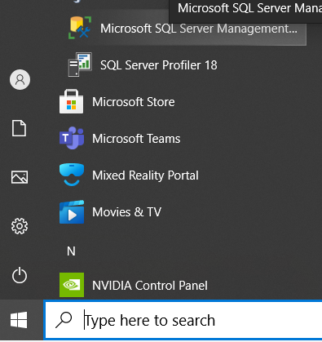

* 1. Login to the DB server using “Windows Authentication”

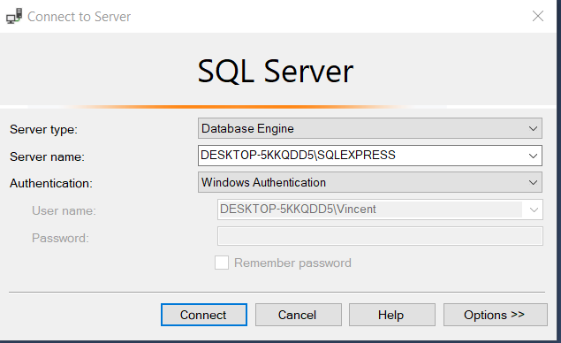

* 1. After the successful login, create an admin user by following the procedure below;

File 🡪 Open 🡪 File C:\GSRS Automation 2021 v2 Setup\Create_DBUser.sql

Select all using “CTRL+A” and Click on “Execute” button.

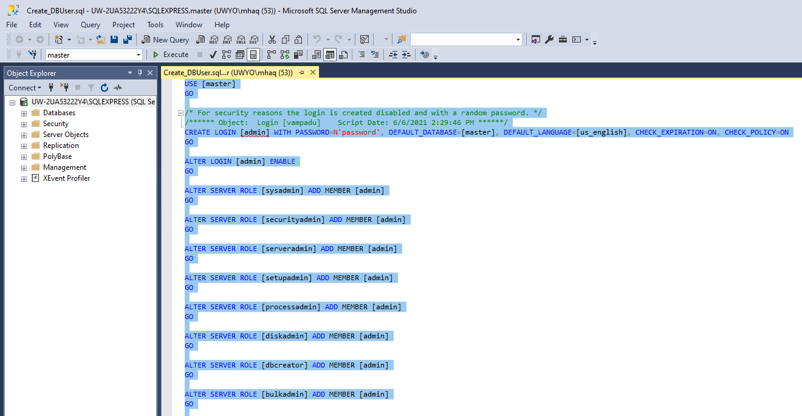

* 1. Right Click on SQL Express Icon in the left panel, to enable SQL Server Authentication mode

* + 1. Properties 🡪 Select Security Tab and Select “SQL Server …” option & “Failed logins only” then click “OK”.

* + 1. Click OK, and Restart SQL Server Express by following below steps

RUN command 🡪 services.msc 🡪 Scroll to “SQL Server Express” server and Right click 🡪 Restart.

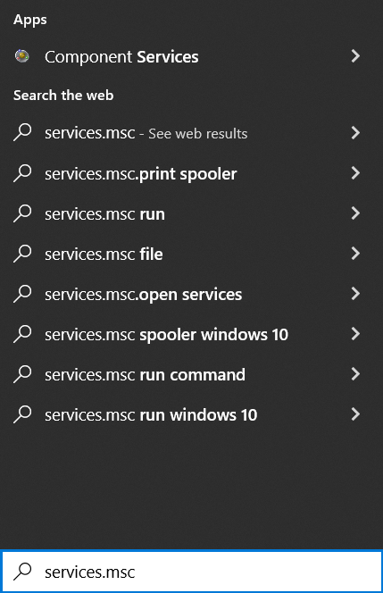 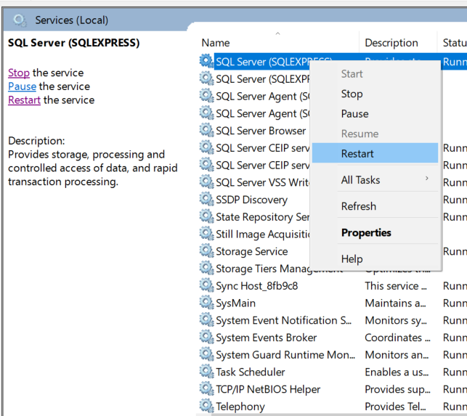

* 1. Close Microsoft SQL Server Management Studio and log back in using the Admin User, with SQL Server Authentication as show below;

“Login – admin, Password – password and click on Connect”

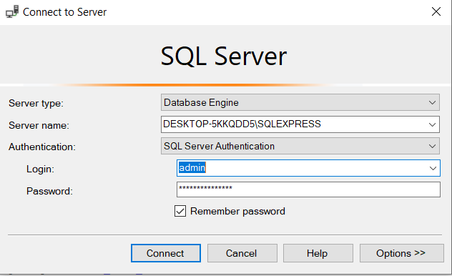

* 1. Create the GSRS database by executing the query below:

File 🡪 Open 🡪 File C:\GSRS Automation 2021 v2 Setup\Create_GSRS_Database.sql

Select all using “CTRL+A” and Click on “Execute” button

* 1. Run GSRS DB Scripts to create necessary tables and stored procedures by following the procedure below:

File 🡪 Open 🡪 File C:\GSRS Automation 2021 v2 Setup\ Create_GSRS_Tables_SP_Scripts.sql

Select all using “CTRL+A” and Click on “Execute” button, and then close the file.

1. Install the .Net Framework 4.7.2 by clicking on “C:\GSRS Automation 2021 v2 Setup\.Net Framework 4.7.2.exe” and follow the instructions. If .NET framework is already installed, ignore this step.
2. Install GSRS Automation software by clicking on “C:\GSRS Automation 2021 v2 Setup\setup.exe”
   1. Click Next

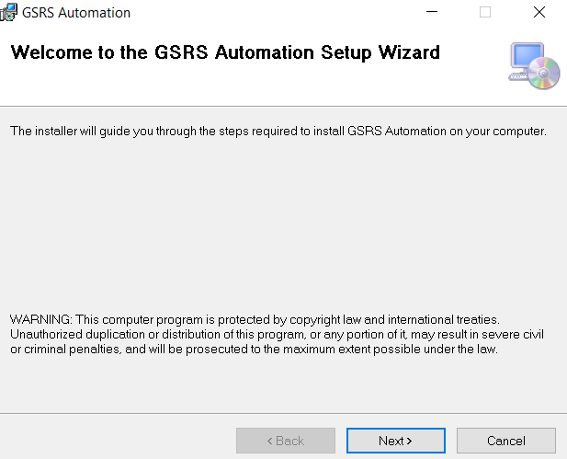

* 1. Choose “Everyone” and leave the default path "C:\Program Files (x86)\", Click Next

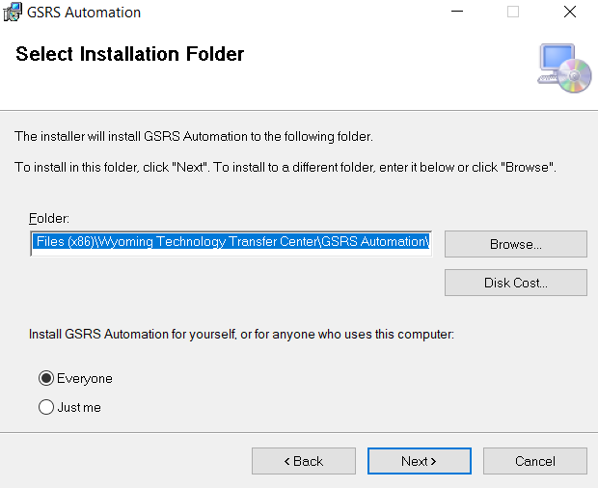

* 1. Click Yes or Next on “next” screens and finally close the application.

(Windows might indicate that “This is an unreliable source to be installed on your computer”). On encountering this, proceed to click “RUN ANYWAY” since no harm is associated with this action.

1. Create GSRS Automation software shortcut in start menu
   1. Right click on C:\GSRS Automation 2021 v2 Setup\create_shortcut.bat and “Run as Administrator”. The software should launch at this point

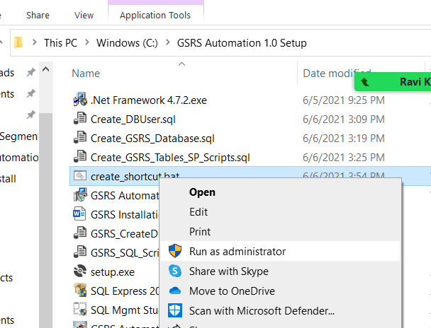

* 1. Alternatively, click on the GSRS Automation icon on the Windows start menu to launch the application.

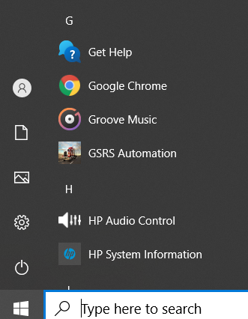

c) As a final option, type “GSRS….” in the search bar in order to locate the software icon to launch it.

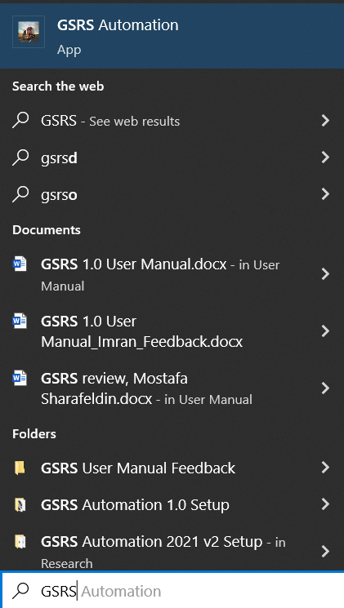

# PRODUCT FEATURES

Below is a brief manual describing the features for the GSRS 1.0 software which should enable any user regardless of their software usage skill level to successfully manipulate the product.

After installation and launching of the product, the login page is the first form that loads.   
For initial use of the product, the admin and username should be supplied as shown in Figure 1.

Username -> admin

Password -> password

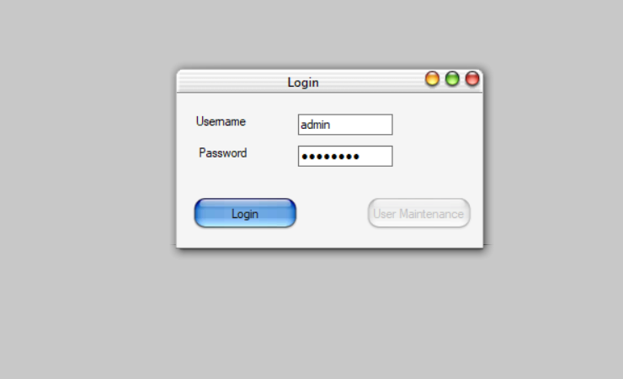

**Figure 1 Login Page.**

Supplying this information and clicking “Login” launches the application. The “User Maintenance” button on the form is now enabled because the default login credentials have been pre-assigned administrative privileges. This can be observed by minimizing or logging out of the “GSRS Auto 1.0” main form.

In order to register additional users of the software and specify their software usage privileges, click on “User Maintenance” (as an administrator). The form shown in Figure 2 below loads

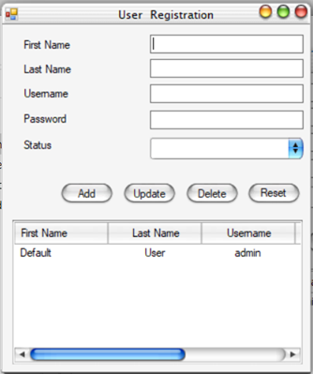

**Figure 2 User Registration Form.**

The default “Last Name” and “Username” of the software is shown in the Listview box. To add additional users, the textboxes representing “First Name”, “Last Name”, “Username”, “Password” and “Status” are populated accordingly. Figure 3 shows a snapshot of one such data entry process

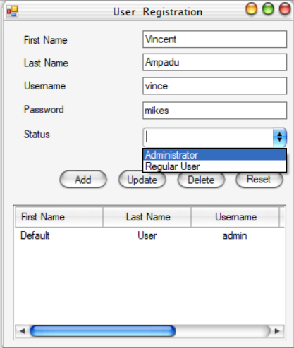

**Figure 3 User Registration Form illustrating a data-entry process.**

It should be noted that under status, the administrator has only two options- to register the user as “Administrator” or “Regular User”. Should he/she register the user as an administrator, that user should be able to both sign into and use the application and have access to the User Maintenance section to manipulate user attributes. On the other hand, if the administrator only grants “Regular User” privileges to a specific user, then even though that user should be able to sign into and use the software, the “User Maintenance” button on the login page would be disabled.

In general, for the User Registration form, besides the default values, in order to update a particular record, click on that record in the listview, modify the relevant field above, click on “Update” and confirm when prompted by the dialogue box to update the record in the database. To delete a record, click on it in the listview, click the delete button and confirm when prompted by the dialogue box. Clicking on “Reset” clears all fields of entries.

Figure 4 shows the continuous slope section of the GSRS software and indicates both the input form on the bottom right and the output form on the top left section. As can be seen, the user is analyzing a downgrade with 7 segments, 500˚F maximum brake temperature, 80,000 lbs maximum truck weight, 65 mph maximum descent speed, 200˚F initial brake temperature, and 90˚F ambient temperature. These fields should be populated by the user based on his knowledge of the relevant variables.

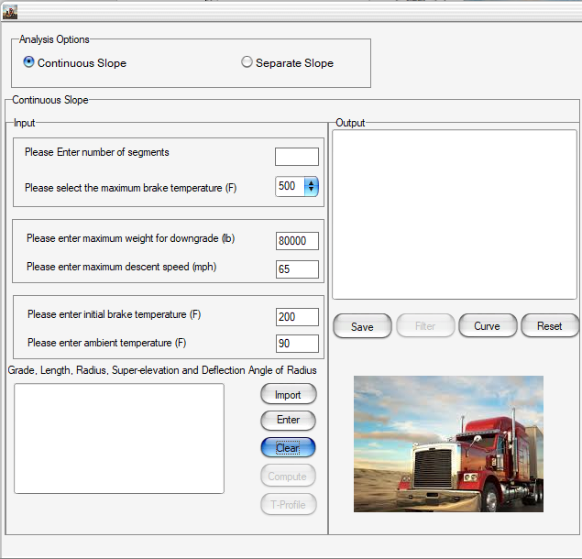

**Figure 4 An Example of Final Output of Maximum Descent Speeds and Other Parameters Based on the Continuous Slope Method.**

The following table represents both a sample and ideal range of values that a knowledgeable user could typically use as input parameters for the continuous slope section of the software.

|  |  |  |
| --- | --- | --- |
| **Parameter** | **Sample** | **Ideal** |
| **Maximum brake temperature (˚F)** | 500 | 500/530 |
| **Maximum downgrade weight (lb)** | 80,000 | 50,000 - 100,000 |
| **Maximum descent speed (mph)** | 65 | 35 - 65 |
| **Initial brake temperature (˚F)** | 200 | 150 |
| **Ambient temperature (˚F)** | 90 | 90 |

# DATA PREPARATION

In order to prepare the data which constitutes the physical characteristics of the downgrade, the following procedure is followed:

For the physical characteristics of the downgrade, the input data required to obtain the maximum safe descent speeds include the longitudinal grade of the segment (%), the length of the segment (miles), radius of the horizontal curve (ft), the super-elevation of the segment (%) and the deflection angle of the horizontal curve (degree). The software enables either a manual entry of the data or the capability to import the data from an excel sheet.

In order to use the manual entry feature of the software, the user should click the “Enter” button. A dialogue box pops up and prompts him to enter the number of segments if he hasn’t already done so. If the number of segments entered is less than or equal to 6, successive dialogue boxes appear and collect all the physical downgrade data for each successive segment. It should be noted that the user needs to complete the entire data collection cycle before being allowed to exit the input box. If the number of segments entered is more than 6, a dialogue box pops up and queries the user if he would like to import the data. If he clicks on “no”, several dialogue boxes manually requesting for data one segment at a time pop up as before. Figure 5 represents a snapshot data entry stage of the software input for this specific instance of the data collection stage.

**Figure 5 Entering the physical downgrade parameters manually.**

If he clicks on “yes”, then an open dialogue box appears to allow him to navigate to the excel file into which he has collated all the segment data. This step is indicated in Figure 6 below

**Figure 6 Importing the physical downgrade parameters from excel.**

Figure 7 represents a snapshot for an excel datasheet showing a typical structure for the input data representing the physical characteristics of the downgrade and the roadway geometry ready for importation into the software.

As stated before, the data required to populate the excel sheets prior to importation are the grade, segment length, radius of horizontal curve, super-elevation of the segment and the deflection angle of the horizontal curve. These should be entered from the first to the fifth column; with each row collecting the data for each segment.

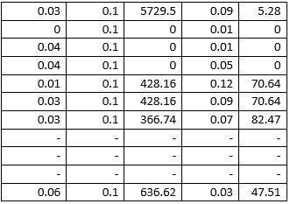

**Figure 7 A Snapshot for a Sample Excel Datasheet representing the Physical Characteristics of the Downgrade and the Roadway Geometry.**

The deflection angle of the horizontal curve can be calculated from the radius and length of the segment through equation 1 below

Where is the deflection angle of the horizontal curve, Lc is the length of the curve (ft) and R is the radius of the curve (ft).

# CONTINUOUS SLOPE METHOD

After the data is imported or manually entered, whichever is the case, the user clicks on “Compute” and the Output field is populated by the output of the continuous slope method which consists of the Maximum Weight, Maximum Speed, Descent Temperature, Emergency braking Temperature, Final brake Temperature and Time to descend the downgrade. At this juncture, the user can either click on “Save” to save the output or “Filter” to filter down the output to the values of these parameters at each weight category from the maximum weight to 0 lb. It should be noted that the horizontal curve input parameters are excluded from the computation of these results- (Radius of horizontal curve, super-elevation of the segment and the deflection angle of the horizontal curve).

By clicking on “Curve”, the overall output is computed- this time incorporating the input parameters introduced by considering horizontal curves. As before, the user can click on “Save” to save the output or “Filter” to filter the results in order to pare down the output to the values for each weight category from the maximum weight to zero, as shown in Figure 8.

If the user wants to determine the Temperature profile for the grade descent, he clicks on the “T-Profile” button and the form on the left of bottom image of Figure 8 pops up. He then clicks on “Compute” and the form shows all the results for the output inclusive of which is the Maximum Weight, the Speed, the Distance (in miles) from the start of descent (in 0.5-mile increments), the grade, the descent temperature, the emergency braking temperature and final braking temperature. As before, the user can save this output or filter it to pare down the results to only those with final brake temperature below 500F by clicking on the corresponding buttons on the form. The temperature plot on the right shows the graphical portrayal of the temperature profile based on distance from the start of the downgrade in miles. This form pops up when the user clicks on “Plot”. The red line indicated the maximum brake temperature (500˚F).

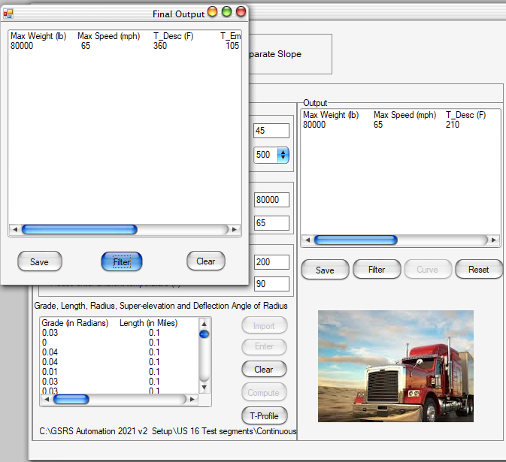

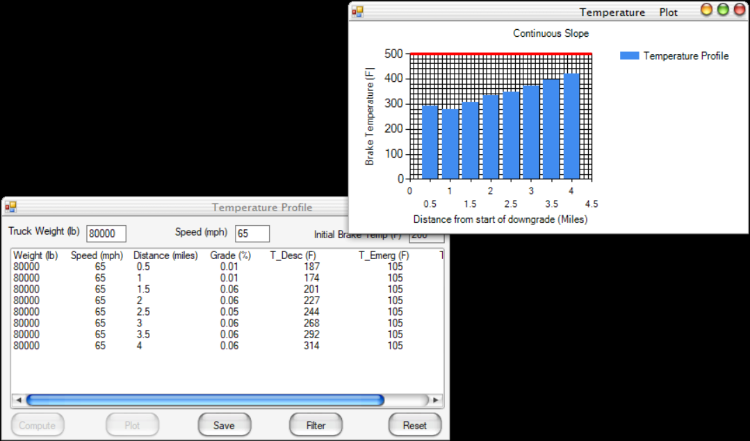

**Figure 8 An Example of Final Output and Temperature profile of Maximum Descent Speeds based on the Continuous Slope Method.**

# SEPARATE DOWNGRADE METHOD

The separate downgrade method is used for multigrade segments composed of clusters of braking and non-braking segments. Braking segments are typically downgrades composed of segments with lengths greater than 0.5 miles whereas non-braking segments are typically upgrades, level segments or downgrades with segment lengths less than 0.5 miles. Figure 9 illustrates an example of multigrade segment which is a typical candidate for the separate downgrade method.

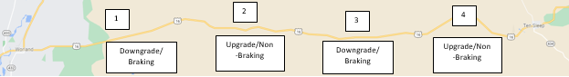

**Figure 9 Aerial view of a typical multigrade segment.**

**Braking**

Figure 10 illustrates a snapshot of the excel data file containing the physical input parameters of the downgrade for this phase.Beneath it isFigure 11 which illustrates the first braking phase of a 2-grade multi-grade with the indicated input parameters on the bottom right as well as the final maximum descent speeds to prevent brake fade, rollover, and skidding on the top left.

**Figure 10 A Snapshot for a Sample Excel Datasheet representing the Physical Input Parameters for the Braking Phase.**

The input parameters besides those of the physical downgrade are mostly the same as those requested for and fed into the continuous slope method. Similarly, the buttons do the exact same thing as described in the preceding sections. The only difference is this method requests for the number of grades (i.e., segments) in the multigrade.

**Figure 11 An Example of the Final Output of Maximum Descent Speeds and Other Parameters for a Typical Braking Phase based on the Separate Downgrade Method.**

The braking phases of the separate downgrade method for the GSRS is signified by odd group numbers (1, 3, 5, …) and typically outputs a single truck weight and associated maximum descent speeds from the speed limit to 15 mph in 5 mph decrements. The final output also includes the temperature of descent (˚F), emergency braking temperature (˚F), total final temperature (˚F), and time to descend the downgrade (min). The “Filter” and “Save” buttons serve the same function as described in the continuous slope method. Moreover, the “Curve” button outputs the results for these given set of input parameters with the horizontal curve parameters included. The “Save” and “Filter” buttons have the same function as before. To proceed to the next group of segments in the non-braking phase, the “Next” button is clicked.

**Non-Braking**

Figure 12 illustrates a snapshot of the excel data file containing the physical input parameters for the non-braking phase.

**Figure 12 A Snapshot of the Excel Data File containing the Physical Input Parameters of the Non-Braking Phase.**

Figure 13 illustrates the first non-braking phase of the same two-grade multigrade with the indicated input parameters as well as the final maximum descent speed to prevent brake fade, rollover, and skidding for various weight categories on the bottom right and top left respectively (In this specific scenario, this maximum descent speed is equivalent to the speed limit for the maximum weight category and hence all lower weight categories can descend safely at the speed limit hence why they aren’t indicated in the display). The functionality for the non-braking phase of the separate downgrade method (with even group numbers- 2, 4, 6, 8, …) for the GSRS is very similar to the continuous slope method. The distinguishing feature of the input parameters for a non-braking phase of a multi-grade downgrade is the “0” grade value for each segment.

**Figure 13 An Example of Final Output of Maximum Descent Speeds and Other Parameters for a Typical Non-Braking Phase Based on the Separate Downgrade Method.**

All buttons have the same functionality as is described in preceding sections. The final output involved in both considering and excluding horizontal curve parameters respectively includes the Maximum Weight, Maximum Speed, Temperature of descent (˚F), Emergency braking temperature (˚F), Total final temperature (˚F), and Time to descend the downgrade (min).

By clicking on the “Next” button on the output form which pops up after clicking on “Curve”, one can navigate to the next group of segments. This process is continued until the maximum number of grades in the multigrade is exhausted. Clicking “Next” following this should generate a dialogue box which alerts the user to the fact that the maximum number of downgrades has been reached and requests to terminate the process and reset all fields.

# ERROR HANDLING

During either the braking or non-braking phase of the continuous/separate downgrade section of the software, it is possible for the user to import a spreadsheet in which any one of the input parameters violates criteria for the appropriate format specified in the algorithm. In this instance, an error dialogue box pops up as illustrated in Figure 14.

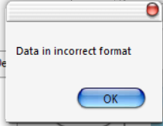

**Figure 14 Error Dialogue box for data entered in incorrect format.**

Alternatively, the spreadsheet may contain downgrade physical characteristic values which violate criteria for satisfying relevant equations. In this scenario, the error indicated in Figure 15 is triggered. The user will therefore be required to reduce the length of the segments and recompute the deflection angles, using equation (2) iteratively until the software no longer triggers that error. To reiterate, equation (2) is listed underneath as follows:

It is important that the user notes how changing the length of the segment will influence other parameters associated with it such as the radius, grade and super-elevation of this new length and modify it accordingly in the datasheet.

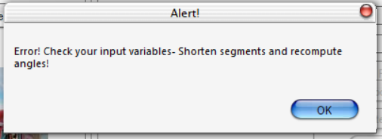

**Figure 15 Error Dialogue box for data values violating criteria for in-built equations.**

An audio-video version of this user manual will be available to provide better guidance to the user soon.